DATA model is nothing but creation of objects and relationships

MVC is the architecture used in salesforce

M-Model

v-view

c-Controller

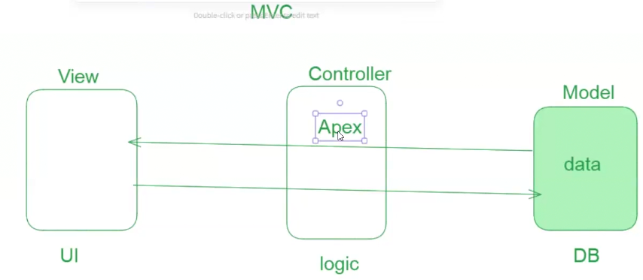

we can write the code through formulae editor

Console is a space where we can write the logic

The above is an error which is given by the compiler